ELECTRIC KETTLE

ELECTRIC STEAM IRON

|  |  |  |  |
| --- | --- | --- | --- |
| philps | Sharp | Haier | Panasonic |
| Tefal | Beldray | Funky | Tower |
| Russell Hobbs | Breville | Morph Richards | Ailyons |
| Boss | Hitachi | Beko | Kodtech |
| Sanyo | Admiral | Eureka | Zec |

AC

SCIENTIFIC CALCULATOR

WATER DISPENSER

BRENDER

SUBWOOFER

SOUNDBARS

SMARTWATCH

WATCH

CARS

TELEVISION

PROJECTORS

|  |  |  |  |
| --- | --- | --- | --- |
| EPSON | HITACHI | SONY | Panasonic |
| BENQ | NEC | SAMSUNG | YAMAHA |
| Acer | HP | DELL | Braco |
| Christie | Chief | JVC | Infocus |
| View Sonic | Dangabei | Optoma | 3M |
| Miele | Mitsubishi | Philps | Polaroid |
| XGIMI | Bretford | Vogels | Vista |
| Premier mount | TOSHIBA | SHARP | Proxima |
| JMGO |  |  |  |

PHOTOELECTRIC SENSOR

Types

|  |  |  |
| --- | --- | --- |
| **Through-beam photoelectric** | **Retroreflective photoelectric** | **Diffused photoelectric** |

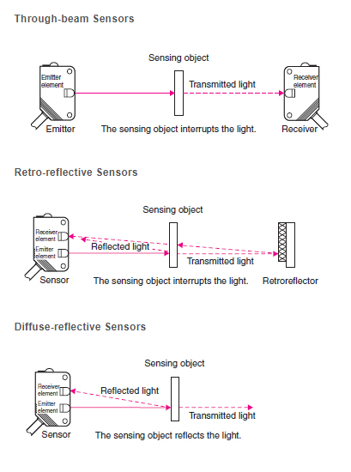

AI DATA LABELLING AND ANNOTATION

|  |  |  |
| --- | --- | --- |
|  |  |  |
|  |  |  |

GENERATORS

|  |  |  |  |
| --- | --- | --- | --- |
|  |  |  |  |

ROBOT DEDICATED

AIR COOLER

BIOINSPIRED ROBOT

DIGITAL MULTIMETER

|  |  |  |
| --- | --- | --- |
| FLUKE | UNI-T | ZOYI [ZOTEK] |
| MASTECH | HIOKI | HTC |
| SANWA | TRONIC | DURATOOL |
| PLUSIVO | KAIWEETS | KLEIN |
| ASTROAI | CRENOVA | NEOTECK |
| Gardner Bender GB | MILWAUKEE | White Deer |

On The Go (OTG)



|  |  |
| --- | --- |
|  |  |

OTG USB is a specification introduced in late 2001

allows USB devices, such as [tablets](https://en.wikipedia.org/wiki/Tablet_computer) or [smartphones](https://en.wikipedia.org/wiki/Smartphone), to also act as hosts, allowing other [USBs](https://en.wikipedia.org/wiki/USB) to be attached to them. Use of USB will enable devices to switch back and forth between the roles of host and device.

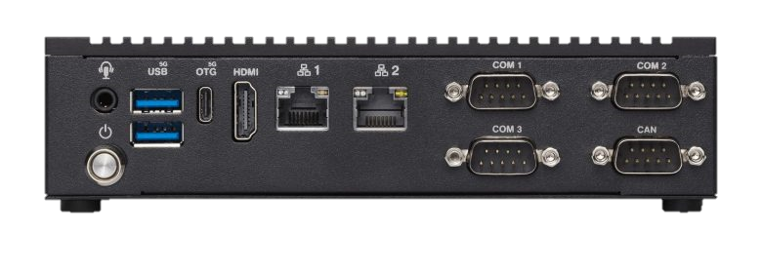

SENSOR

Flame Rod Sensor

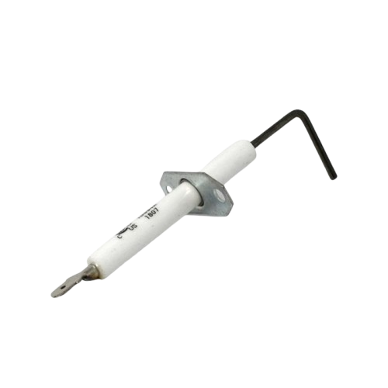

**Pin Description**

1. **VCC**: Power supply pin (usually 3.3V or 5V).
2. **GND**: Ground pin.
3. **DO:**  Digital output (high when flame detected).
4. **AO**: Analog output (provides varying voltage based on flame intensity).

**Applications**

1. Fire detection and alarm systems
2. Industrial flame monitoring
3. Gas leak detectors
4. Robotics projects involving flame detection

RESISTORS

|  |  |  |
| --- | --- | --- |
| Carbon Film resistor | Metal Film resistor |  |
|  |  |  |
|  |  |  |

CONVEYOR BELT

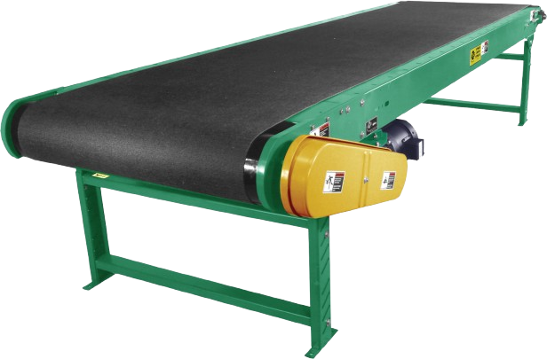

Tools and Materials to repair a teared conveyor belt

|  |  |  |
| --- | --- | --- |
| Right angle ruler | Tape measure | Stanley Knife |
| Belt Cement and hardener | Painting Brush | Rubber hammer |
| Tuck Pointer | Knife | Sharpening stone |
| Grinder | Pincer |  |